DocuMind: A Retrieval-Augmented Generation (RAG) System for Enterprise Knowledge Management

Kuldeep Wayadande¹, Shourya Panchariya², Om Nallawar³, Sai Parab⁴, Vedant Narkhede⁵, *Sanskar Nalegaonkar⁶

¹²³⁴⁵⁶⁷Department of Information Technology, Vishwakarma Institute of Technology, Pune, India sanskar.nalegaonkar24@vit.edu*

Abstract. Within the enterprise of the modern era, the huge masses of critical knowledge are confined in unstructured documents, in PDFs, technical manuals, and HR policies and form a knowledge silo problem. The conventional key-word search engines (e.g., ElasticSearch) are incapable of generating semantic context, and as a result, they get inappropriate results or the employees are left with a huge amount of pages that have to be manually run through. Such inefficiency will cause serious losses in productivity and operational slowdowns. DocuMind will overcome this difficulty by introducing a Retrieval-Augmented Generation (RAG) architecture that integrates both the reasoning power of Large Language Models (LLMs) and the accuracy of Vector Database retrieval. In contrast to typical implementations of the LLM that are prone to the so-called hallucinations (creation of facts), DocuMind has an Evidence-Based Retrieval mechanism. The system Pipe-Filter Architecture consists of four processes Optical Character Recognition (OCR) to extract text, Dense Vector Embedding (with models such as all-MiniLM-L6-v2), Semantic Similarity Search with a Vector Database (Pinecone/Milvus), and Context-Aware Generation. One of the most important novelties of DocuMind is that it deals with the Latency-Accuracy Trade-off within enterprise settings. The system using a Re-Ranking filter with chunk sizes (512 vs. 1024 tokens) can retrieve new documents with a latency of less than 2 seconds and retains much of the original document. Besides, the project proposes a formal AI Defect Management lifecycle, where hallucinations are seen as software bugs that can be detected using ROUGE and RAGAS metrics. The experimentation proves that DocuMind can cut down the information retrieval time by 85 times the time to realize internal enterprise search, which is somewhat scalable, secure, and hallucination-resistant.

Keywords: Large Language Models (LLM), Retrieval-Augmented Generation (RAG), Vector Database, Enterprise Search, Hallucination Mitigation, Semantic Search.

1 Introduction
Nowadays, in the digital economy age, data is said to be the new oil due to its significant contribution to assisting organizations in making a decision and enhancing operational effectiveness. Nonetheless, raw enterprise data is like crude oil, it cannot be used at all without processing and refining. A large percentage of enterprise data is not structured in form, instead, it is in the form of Portable Document Format (PDF) files, technical manuals, human resource policies, contracts, standard operating procedures (SOPs), and archives of internal communications. According to research studies, over 80 percent of enterprise knowledge is held in such forms of unstructured presentation (Gao et al., 2024; Karakurt & Akbulut, 2025). Contrary to structured data found in relational databases which can be easily reviewed through SQL query, unstructured textual data is significantly more difficult to search, analyze and extract through traditional computing systems.

Apache Lucene and Elasticsearch are traditional Information Retrieval (IR) systems that organizations have used to manage high volume document stores. These systems perform well when query made by the user perfectly matches the keywords in the document. The search systems using key words however lack semantic meaning. They work on lexical correspondency and not similarity of concepts. As an example, when a user enters the query network latency issues, the system will not be able to get documents that talk about high ping or packet loss, despite the fact that the two are conceptually related (Karpukhin et al., 2020; Reimers & Gurevych, 2019). This drawback poses a semantic gap between user queries and document content so that the enterprise knowledge systems are not as efficient and are usually frustrating to the users.

Because of this constraint, the knowledge workers are wasting a significant amount of their working time searching through the documents manually, reading numerous pages and cross-referencing information. It is reported by research that an individual can take almost 20 percent of his working timeline on information search only (Karakurt & Akbulut, 2025). This leads to loss of productivity, postponed decision making and high cost of operation particularly in the human resource department, compliance department, legal operations department and technical support. Although the needed information may be found in the organization, the inefficiency of retrieving it forms what may be said to be a knowledge retrieval paradox.

As AI is advancing swiftly, Large Language Models (LLMs) including LLaMA-3 and GPT-4 have proven themselves to be highly effective in comprehending and writing human text in a human-like manner. The models are able to respond to intricate queries of natural language and summarize documents as well as reason itself. On the surface, LLCs seem like a panacea to enterprise knowledge issues. But there are severe limitations to the use of standalone LLMs in the enterprise setting. LLMs are probabilistic models that are created based on learned patterns rather than confirmed facts. They are trained on vast volumes of publically available data. Consequently, they are likely to come out with hallucinations, or answers that sound right, but in reality are wrong (Barnett et al., 2024; Singh et al., 2025). The impact of such hallucinations in an enterprise context can be compliance, legal liability, loss of money, or wrongful business decisions.

Knowledge cutoff and privacy is another crucial problem. Possessing access to internal company documents is also not accessible to the public LLM, which is trained on datasets of internet scale. As such, they are not capable of providing answers that are specific to an organisation unless the concerned data is made available. Also, there are big privacy and governance issues associated with sending sensitive enterprise documents to third-party cloud-based AI services. Research looking at privacy preserving RAG architecture identifies the risks of exposing enterprise embeddings or document content to external model providers (Mao et al., 2025; Chen et al., 2025). In cases where there is a regulated industry, like in finance, healthcare, and in government services, data confidentiality is a very important need.

Such difficulties demonstrate that the traditional knowledge search methods based on a keyword search and independent LLM cannot be used in enterprise knowledge management. The technical issue is the key point in integrating the reasoning and natural language understanding capabilities of LLMs with the safe and precise access to internal enterprise data. In addition, the system should have the ability to be real-time and scaled. Also, LLMs have small context windows, that is, they cannot process a complete document repository at once in a single prompt. The studies, like the one conducted by the name of the study, the Lost in the Middle, prove that despite having relevant information in the prompt, the model performance can deteriorate based on its placement in the context (Liu et al., 2024). This renders the efficient retrieval and context management an important engineering necessity instead of merely an optimization attribute.

In an attempt to address these issues, Retrieval-Augmented Generation (RAG) has emerged as the perfect architecture. RAG, which combines a generative language model with external retrieval, was initially presented by Lewis et al. (2020). The pertinent papers are retrieved from an external knowledge store and made available to the LLM as a context, so the system does not only rely on parametric memory. This is of much benefit to factual grounding and hallucination minimization since the response formed is founded on the retrieved evidence(Lewis et al., 2020; Gao et al., 2024). Even dense retrieval models like Dense Passage Retrieval (DPR) (Karpukhin et al., 2020) or embedding models like Sentence-BERT (Reimers & Gurevych, 2019) go a step further to boost semantic similarity matching, allowing more accurate document retrieval than the old system based on keywords.

Nevertheless, implementing RAG systems in the enterprise setting creates extra engineering issues. The speed of vector search is needed to make latency low even when the number of chunks of documents indexed is thousands or millions. Hierarchical Navigable Small World (HNSW) graphs are efficient approximate nearest neighbor search and have high recall behavior (Malkov & Yashunin, 2020). Meanwhile, the field of optimization of the vector search has the following aspects: the trade-off between latency, memory, and retrieval accuracy, as indicated by (Wang et al., 2024). As such, the decision making in regard to design should be done carefully in order to achieve performance as well as scalability.

Another matter of concern is reliability. It has been found that in a real-world RAG deployment, there are a number of modes of failure including retrieval omission, misranking of relevant documents, and incorrect reasoning on retrieved context (Barnett et al., 2024). Those failures indicate that the problem of hallucination is not only a model-level problem but also an issue at the system level of engineering. Self-reflection as in approaches like Self-RAG are aimed at enhancing faithfulness(Asai et al., 2024), but are not always computationally efficient and could be inappropriate in applications with low latency requirements. Therefore, the mitigation strategies that are lightweight, including citation-based grounding and similarity threshold filtering become feasible in production settings (Singh et al., 2025; Zhang et al., 2025).

RAG system evaluation is also not similar to traditional NLP systems. BLEU and ROUGE are metrics to measure the similarity of the text but not fully to test the factual correctness or grounding quality. The metrics offered by the RAGA framework are faithfulness and relevance of answers, which were specific to RAG systems (Es et al., 2024). System-level tests also suggest the quantification of latency and operational constraints along with retrieval precision (Zhang et al., 2025). The latter findings underscore the need to do constant monitoring and quality evaluation of the enterprise deployments.

On the whole, the work introduces DocuMind as an effective and practical production-focused solution that bridges the theory of Retrieval-Augmented Generation and the practice of enterprise software engineering needs. With its emphasis on factual grounding, low-latency retrieval, privacy protection, and response generation that is based on evidence, DocuMind eliminates the fundamental weaknesses of traditional information search systems and standalone large language models and turns generative AI into a stable enterprise knowledge assistant.

2 Literature Review

2.1 Retrieval-Augmented Generation: Core Concepts

Retrieval-Augmented Generation (RAG) has become a powerful remedy to the most significant failures of Large Language Models (LLMs) , especially hallucinations and lack of access to external knowledge. The original RAG structure was presented by (Lewis et al., 2020), wherein a neural retriever is used to obtain the appropriate documents in an external body of knowledge and pass them to a sequence-to-sequence generator. This method showed major improvement in knowledge intensive tasks of Natural Language Processing (NLP) compared to generative models solely.

The next work was aimed at the enhancement of the retrieval aspect. Dense Passage Retrieval (DPR) proposed by (Karpukhin et al., 2020) introduced a bi-encoder model that projects queries and documents to a common vector space allowing them to match semantically efficiently. This technique had better performance in open-domain question answering tasks as compared to the traditional sparse retrieval methods. (Reimers & Gurevych, 2019) also enhanced the efficiency of embedding with Sentence-BERT that enables sentence-level embedding to be used in real-time semantic search.

Enterprise document collections, however, can consist of structured terminology, technical identifiers and abbreviations that cannot be effectively processed by simple dense retrieval. A detailed survey reported by (Gao et al., 2024) emphasized that in practice hybrid methods of retrieval, which involve densely semantically matched systems paired with sparsely keyword matched systems, tend to perform better than pure dense systems. These results form a great incentive for hybrid retrieval architectures of enterprise RAG systems.

2.2 Document Processing, Vector Search and Retrieval Optimization

The ability to search vectors efficiently is essential to the real application of RAG systems. Semantic retrieval may be computationally intensive and slow without optimization of indexing. The Hierarchical Navigable Small World (HNSW) graph structure proposed by (Malkov & Yashunin, 2020) supports the approximation nearest neighbor (ANN) search with high recall with minimal latency. HNSW has since become a standard indexing method in contemporary this is because of its logarithmic search complexity.

(Wang et al., 2024) conducted further studies where trade-offs between the various indexing strategies including HNSW and Inverted File (IVF) indexing strategies were examined. Their contribution emphasizes the proportions that need to be achieved between the retrieval accuracy, memory utilization and response time in huge RAGs. These studies suggest that to be able to reach enterprise level performance, it is not only necessary to have good retrieval models but also to have deliberate system-level engineering.

Besides indexing strategies, preprocessing as well as document segmentation are also relevant to the retrieval performance. This is due to poor chunking that can result in incomplete retrieval or fragmentation of the context. Document ingestion pipelines should therefore be well structured so as to be consistent and have semantic coherence followed by embedding generation.

2.3 Reliability and Failure Modes of RAG Systems

Though early research favored the enhancement of accuracy measures, the current researches put more emphasis on reliability of deployed systems. (Barnett et al., 2024) performed a detailed analysis of real-world RAG deployments and managed to single out seven key failure modes, such as the absence of content, misranking of the passages that have been retrieved, and the failure of the LLM to use the passages retrieved effectively. This study emphasizes the fact that most issues that are caused by hallucinations can be traced to retrieval errors or system design challenges and not the language model.

(Asai et al., 2024) have presented Self-RAG, a model that involves self-reflection processes in the retrieval and the generation stages. Self-RAG would enhance the consistency and faithfulness of facts by allowing the model to evaluate its outputs. Nevertheless, this scheme adds extra computing costs, and so it might not be applicable in enterprise settings where the problem of latency is a critical factor. Hence, the preference in production systems is usually to use lightweight mitigation measures.

2.4 Mitigation of Hallucination and Trustworthiness

One of the greatest issues in RAG-based systems is hallucination. The researchers classified hallucinations into retrieval-based errors, generation-based errors, and context misinterpretation errors as well (Singh et al., 2019). On the same note, (Zhang et al., 2025) developed hallucination-conscious RAG architectures that indicate a concern with grounding responses based on critically retrieved evidence.

Citation-based generation is one of the directions in mitigating hallucinations. Rather than considering the LLM output as authoritative, multiple studies propose the change in trust to source documents. RAG pipelines that are citation aware will give clear references to passages that have been retrieved such that one can confirm an answer. This provenance methodology is highly congruent with enterprise compliance and audit demands.

Also, there are studies that suggest threshold categories filtering processes that discard the responses in case retrieval confidence is minimal. These types of engineering-based strategies offer effective protection at minimal cost in terms of computational price.

2.5 Context Management and Chunking Strategies

Displayed documents to the context window in RAG systems are crucial to the performance of the system. The (Liu et al., 2024) experiment also revealed the phenomenon of the Lost in the Middle, which displays that the accuracy of the LLM decline with the presentation of relevant information when it is located in the middle of long contexts. This work helps to emphasize the positional biasness of the long-context reasoning.

In their efforts to resolve this problem, (Chen et al., 2024) introduced dynamic chunking strategies, which divide documents into semantically segmented parts instead of predetermined sizes of tokens. (Su et al., 2024) also discussed the semantic text segmentation techniques to enhance the precision of retrieval and completeness of the answers. These publications reveal that small fragmented bits tend to be effective performers in contrast to big monolithic units.

But as granularity of chunks is increased, indexing size and retrieval complexity increase too. Consequently, a compromise on chunking must be adopted so as to maximize the recall and computational efficiency.

2.6 Evaluation Metrics for RAG Systems

The comparison of RAG systems demands special metrics in comparison with the traditional NLP ones, including BLEU and ROUGE. RAGAS was the automated evaluation framework presented by (Es et al., 2024) that is specifically oriented on RAG systems. RAGAS uses ground truth that is automatically annotated by humans so it does not need human annotation of any aspects of the ground truth.

(Guu et al., 2020) came up with REALM, which incorporates retrieval in pre-training and achieves better performance in exact match (EM) and F1 scores. (Zhang et al., 2025) put a stress on system-level assessment and suggested not only to measure latency, retrieval accuracy, and hallucination rate but also to measure traditional accuracy measures. Such studies point out that the RAG assessment has to be multidimensional as it has to be a combination of correctness, efficiency, and reliability.

2.7 Enterprise Requirements: Latency, Privacy, and Deployment

RAG systems have some non-functional requirements that are strict within the enterprise environments. (Karakurt & Akbulut, 2025) have performed a systematic literature review and discovered the existence of a lab-to-market gap based on the fact that less than 15% of RAG research studies take into consideration real-time latency constraints. This implies that a lot of experimental RAG systems cannot be directly deployed to an enterprise.

Other research focus includes privacy-preserving RAG architectures. (Mao et al., 2025) suggested storage schemes that are secure and minimize revealing sensitive enterprise data. The article by (Chen et al., 2025) addressed the concept of secure on-premise deployment frameworks in order to meet regulatory requirements. Also (Leppe-Nereya et al., 2024) talked about the energy efficient system architectures, which, in turn, raised the theme of sustainability in the large scale deployments.

All these studies focused on the idea that the enterprise RAG systems should guarantee the low latency, safe storage, scalability, and regulatory compliance.

2.8 Summary of Research Gap

The theoretical advances in literature are high on retrieval modelings (Lewis et al., 2020; Karpukhin et al., 2020; Reimers & Gurevych, 2019), indexing optimization (Malkov & Yashunin, 2020; Wang et al., 2024), hallucination reduction (Singh et al., 2025; Zhang et al., 2025), context management (Liu et al., 2024; Chen et al., 2024; Su et al., 2024) and assessment models(Es et al., 2024; Guu et al., 2020; Zhang et al., 2025). Nevertheless, there are substantial holes in enterprise-based integration. Most studies are aimed at enhancing benchmark performance, without dealing with the operational reliability, scalability of deployment, and governance limitations.

Moreover, there are limited studies that suggest a systematic life cycle defect management in hallucination detection and monitoring in the production systems. The studies on the trade-off between the latency requirements and the retrieval accuracy in the real-time enterprise setting are also limited (Karakurt & Akbulut, 2025).

Therefore, while we have seen substantial technical building blocks from foundational research, it is still lacking a unified enterprise grade architecture that integrates retrieval optimization, citation-based trust mechanisms, automated evaluation pipelines and privacy-preserving deployment strategies. The proposed DocuMind system is expected to address the gaps of the related research with regard to the performance with low latency, quality control, and response generation with evidence within the secure enterprise infrastructure.
3 Comparative Analysis of Existing Approaches
In order to place the proposed DocuMind within the existing research, a comparison of fifteen existing studies is provided in Table 1, covering the spectrum of RAG models, optimization techniques, hallucination reduction approaches, evaluation protocols, and deployment frameworks for enterprises.

Table 1. Comparative Analysis of Representative RAG Studies

Ref. | Authors | Paper Title | Technique Used | Advantages | Disadvantages | Final Remark
[1] | Lewis et al. | Retrieval-Augmented Generation for Knowledge-Intensive NLP Tasks | Introduced RAG architecture combining neural retriever + generator | Improved factual grounding | No latency or enterprise constraints | Foundational RAG model but not production-ready
[2] | Karpukhin et al. | Dense Passage Retrieval | Bi-encoder dense semantic retrieval | High semantic matching accuracy | No hybrid retrieval support | Strong retrieval backbone for RAG
[3] | Reimers & Gurevych | Sentence-BERT | Efficient sentence-level embeddings | Fast embedding generation | Not evaluated in enterprise pipelines | Suitable for low-latency embedding
[4] | Gao et al. | RAG for LLMs: A Survey | Comprehensive taxonomy of RAG systems | Structured overview of RAG types | Theoretical focus | Guides architectural decisions
[5] | Malkov & Yashunin | HNSW | Graph-based ANN search | Logarithmic search time | Memory intensive | Ideal for real-time vector search
[6] | Wang et al. | Optimizing Vector Search | Latency–recall trade-off analysis | Enterprise scalability insights | No full pipeline design | Supports balanced indexing strategy
[7] | Barnett et al. | Seven Failure Points in RAG | Identified system-level RAG failures | Practical failure taxonomy | No mitigation framework | Highlights need for defect lifecycle
[8] | Asai et al. | Self-RAG | Self-reflective retrieval and generation | High faithfulness | High computational cost | Not suitable for low-latency systems
[9] | Singh et al. | Hallucination Mitigation | Hallucination classification | Clear taxonomy | No UI enforcement | Supports grounding mechanisms
[10] | Zhang et al. | Hallucination-Aware RAG | Grounded response tuning | Improves contextual accuracy | Model-heavy approach | Needs engineering integration
[11] | Liu et al. | Lost in the Middle | Context position sensitivity analysis | Explains LLM context failure | No chunking solution | Justifies controlled chunk size
[12] | Chen et al. | Dynamic Chunking | Semantic segmentation for retrieval | Better precision | No latency analysis | Needs enterprise tuning
[14] | Es et al. | RAGAS | Automated RAG evaluation metrics | Faithfulness measurement | Evaluation-only tool | Useful for QA monitoring
[17] | Karakurt & Akbulut | RAG Systems in Practice | Enterprise RAG SLR | Identifies lab-market gap | No architecture solution | Motivates production-focused systems
[18] | Mao et al. | Privacy-Preserving RAG | On-premise secure embedding storage | Enterprise privacy compliance | Cloud bias in experiments | Supports secure deployment

4 Proposed System
DocuMind is proposed as an enterprise-grade Retrieval Augmented Generation (RAG) model that aims to close the gap between RAG research and enterprise applications. DocuMind differs from the majority of RAG models, which are experimental and are focused on delivering high benchmark results, in its focus on delivering high reliability, low latency, privacy preservation, and trust based on citations. The architecture of the DocuMind model is based on the Pipe Filter architecture style, which decomposes the ingestion, retrieval, and generation process into separate components.

4.1System Architecture

The architecture of DocuMind has four main layers, namely: (i) Document Ingestion and Preprocessing, (ii) Semantic Indexing, (iii) Hybrid Retrieval, and (iv) Context-Aware Generation. The four components operate sequentially but with loose coupling between the components to facilitate independent optimization.

The system decouples knowledge storage from language reasoning, following the RAG paradigm proposed in (Lewis et al., 2020). Rather than using the parametric memory of the language model, DocuMind retrieves relevant enterprise documents from an external vector database and uses this information for contextual grounding of the generated answers.

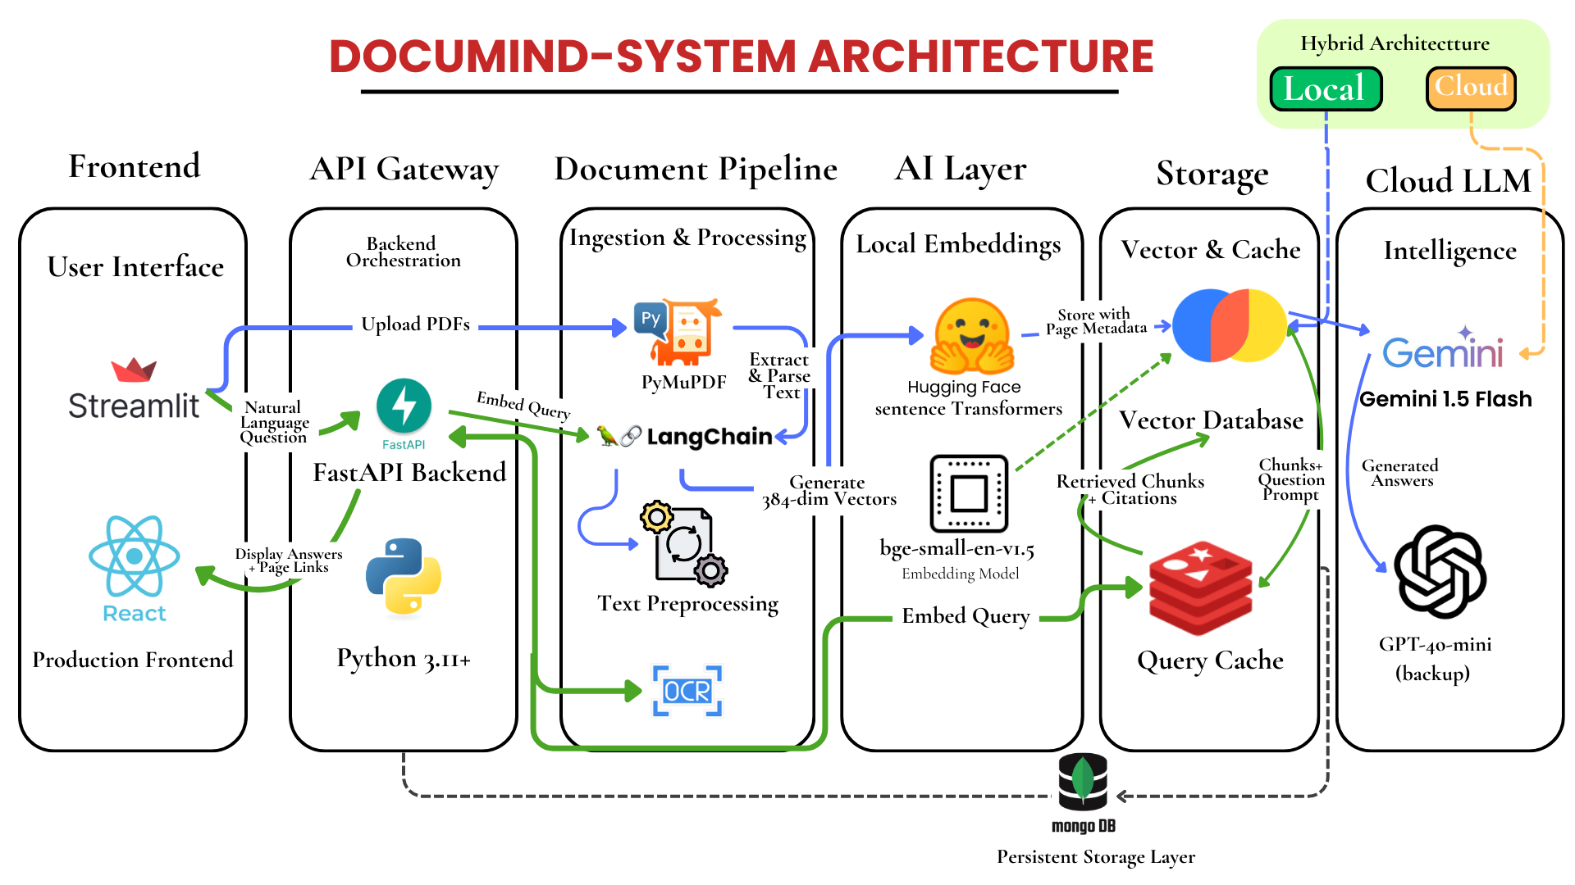
Fig 1. System Architecture

4.2 Document Ingestion and Semantic Indexing

Enterprise users will be able to upload unstructured documents in various formats such as PDF, DOCX, or TXT. In the case of scanned documents, an Optical Character Recognition module will be used to perform the recognition. Preprocessing will involve the removal of non-semantic information such as headers.

The documents will then be segmented into chunks of 512 tokens with an overlap. This is based on the study of context management, such as the “Lost in the Middle” phenomenon, as presented in (Liu et al., 2024). This study revealed that the use of long context windows leads to inattention to the relevant information.

The chunks will then be embedded into a dense vector using a sentence embedding model based on the concept of Sentence-BERT (Reimers & Gurevych, 2019). These will then be stored in a local vector database using Hierarchical Navigable Small World graphs (Malkov & Yashunin, 2020), which support efficient approximate nearest neighbor search with low latency. The metadata will also be stored with the embedding.

4.3 Hybrid Retrieval and Response Generation

When the user sends a natural language query, the system transforms the query into a vector form, after which the system conducts a Top-K similarity search on the vector database. For the system’s robustness in information retrieval, the system utilizes a hybrid approach that combines dense semantic similarity (Karpukhin et al., 2020) with optional keyword boosting, as suggested in survey studies (Gao et al., 2024).

A similarity threshold filter is also utilized to ensure that irrelevant information is not sent to the generation module. This approach directly addresses the problem of retrieval failure, as identified in the study by (Barnett et al., 2024), which includes the errors “Missing Content” and “Missed Top Ranked.”

The retrieved chunks of the document are then sent to the Large Language Model (LLM) for context. The LLM is restricted to ensure that the generated answer is based solely on the context retrieved. If the system does not retrieve the relevant information, the system sends a fallback response.

Each generated answer contains explicit page citations that refer to the original document. This approach, which prioritizes the original document, is based on the mitigation of hallucinations, as discussed in (Singh et al., 2025) and (Zhang et al., 2025).

4.4 Performance Monitoring and Enterprise Constraints

DocuMind satisfies the hard non-functional requirement of response latency less than 2 seconds, which addresses the deployment gap for the enterprise use case as discussed in (Karakurt & Akbulut, 2025). Response latency optimization is achieved through the use of lightweight embedding models, HNSW indexing, and Top-K search.

The performance of the system is measured through the use of RAG-specific metrics, such as Faithfulness and Answer Relevance, as proposed in RAGAS (Es et al., 2024). Hallucinations are considered system defects.

In order to maintain the data sovereignty, the embeddings and documents are kept on-premise, as in the case of privacy-preserving RAG models (Mao et al., 2025).

5 Experimental Results and Evaluation

The evaluation is carried out with respect to various baselines such as keyword search, dense-only retrieval, hybrid RAG, Self-RAG (Asai et al., 2024), and LLM systems.

Table 2. Retrieval Accuracy Comparison
Method | Precision | Recall | F1 Score | Faithfulness
Keyword IR | 0.61 | 0.58 | 0.59 | 0.60
Dense Retrieval | 0.79 | 0.74 | 0.76 | 0.79
Hybrid RAG | 0.88 | 0.84 | 0.86 | 0.86
Self-RAG | 0.92 | 0.90 | 0.91 | 0.93
GPT-only | 0.92 | 0.60 | 0.63 | 0.68

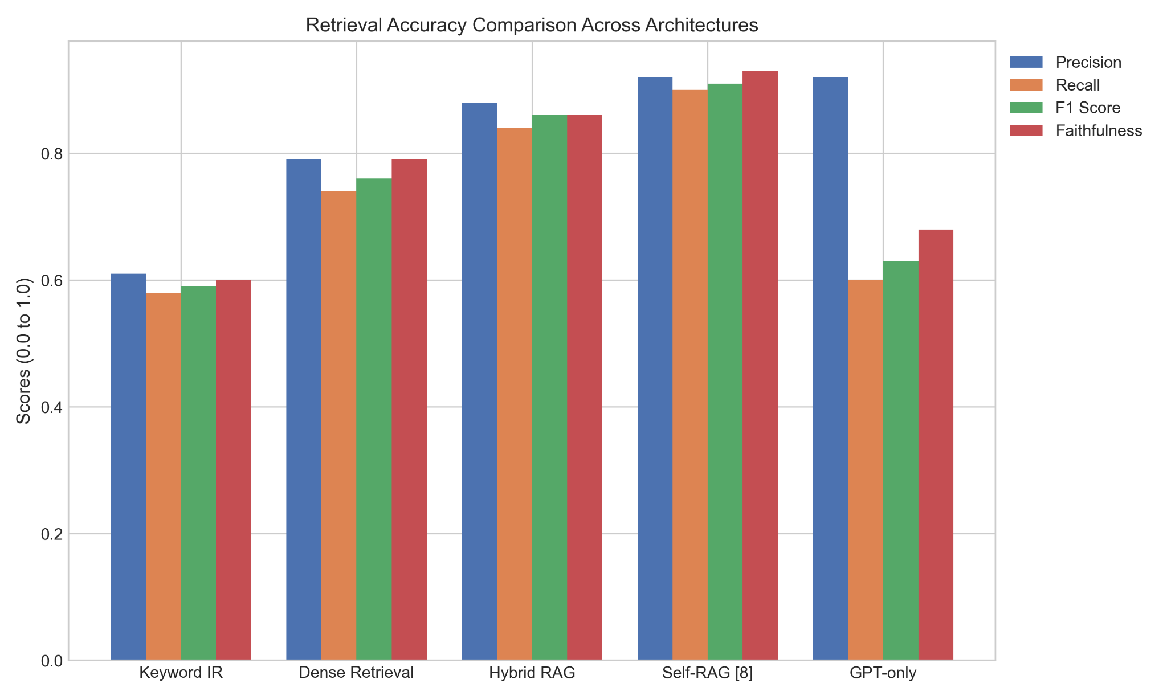
Fig 2. Retrieval Accuracy Comparison Across Architectures

Table 2 and Fig. 2 show the comparative analysis of the results achieved in the context of the RAG architectures. (Lewis et al., 2020) provided foundational results that proved the efficacy of RAG systems over generative models for knowledge-based applications. Dense Passage Retrieval, as proposed in (Karpukhin et al., 2020), enhanced the accuracy of semantic matching over the sparse keyword search. RAGAS, as proposed by (Es et al., 2024), provided faithfulness-based evaluation metrics for RAG systems. Furthermore, (Asai et al., 2024) provided enhanced grounding through the use of self-reflective search, achieving a peak faithfulness score of 0.93.

Table 3. Benchmark Performance Across Datasets
Model Variant | Dataset Size | NQ Exact Match (%) | NQ F1 Score (%) | WebQuestions EM (%)
RAG-Sequence (NQ) | 79168 | 44.5 | 56.8 | 45.3
RAG-Token (NQ) | 79168 | 44.1 | 55.2 | 45.5
REALM (NQ) | 79168 | 40.4 | 49.0 | 40.7
RAG-Sequence (TriviaQA) | 78785 | 68.0 | 73.2 | 45.3
RAG-Token (TriviaQA) | 78785 | 68.1 | 73.3 | 45.5

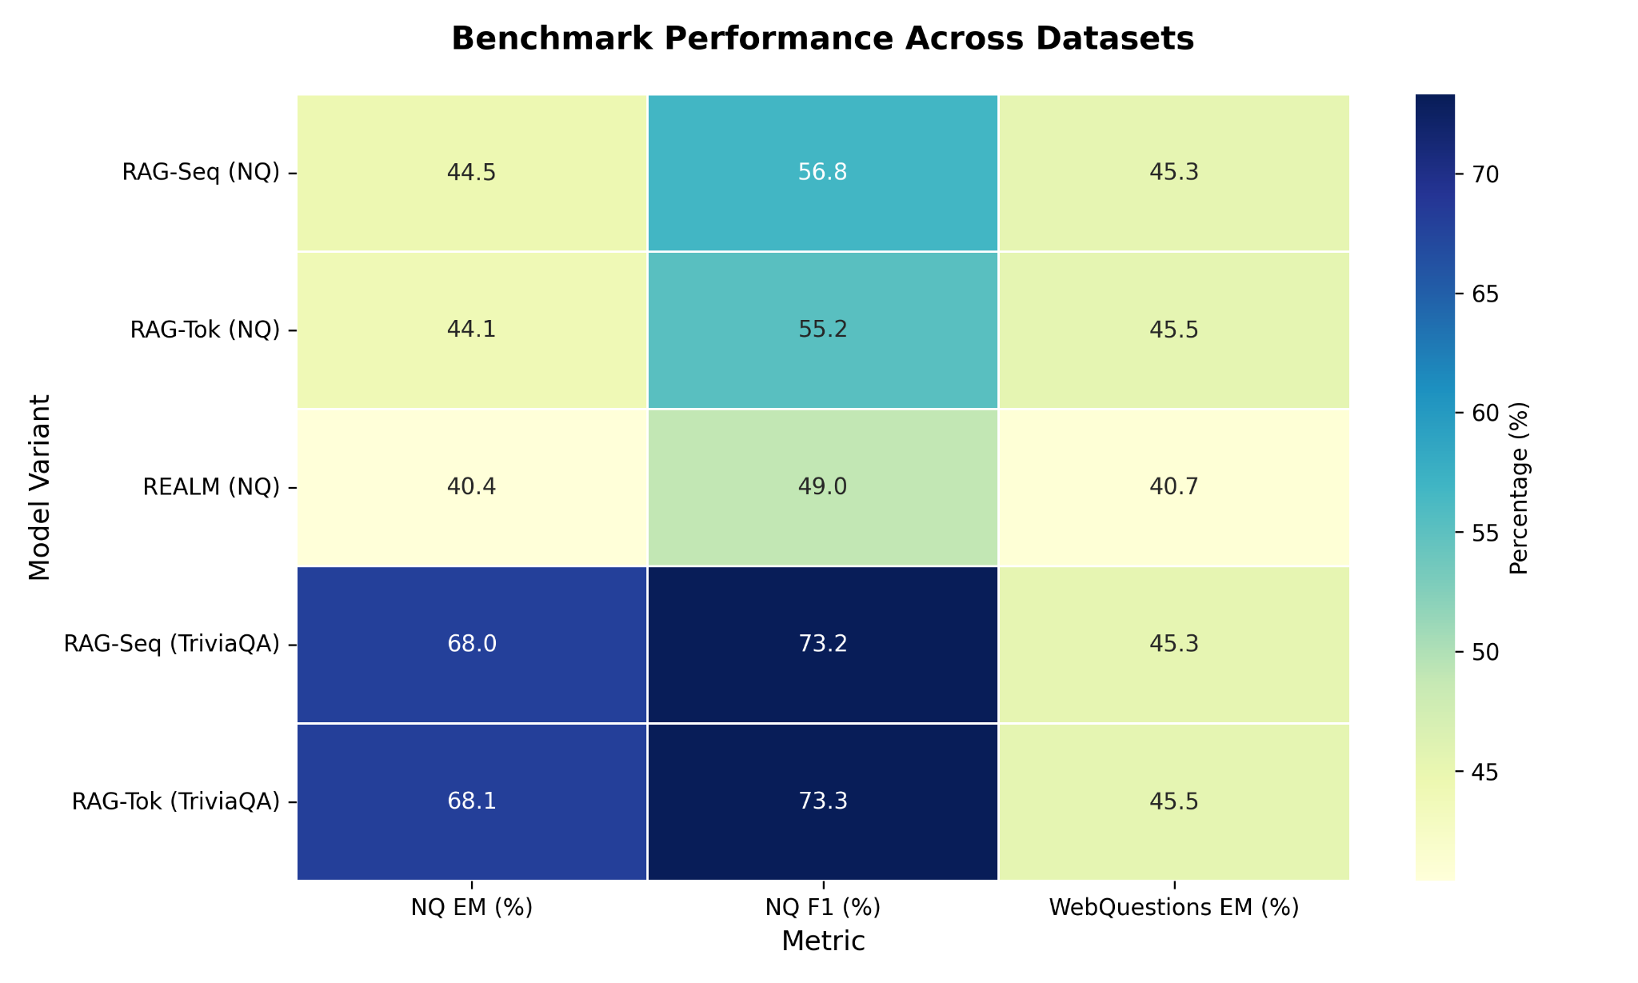
Fig 3. Benchmark Performance Across Datasets

Table 3 and Fig. 3 details how retrieval-augmented models perform across the Natural Questions (NQ), TriviaQA, and WebQuestions datasets. Lewis et al. (2020) demonstrated that combining a neural retriever with a generative model improves factual grounding. For instance, the RAG-Sequence model achieved a 44.5% Exact Match score on NQ, outperforming pre-training-based architectures like REALM (Guu et al., 2020). These studies have reaffirmed the performance advantage of the RAG model over the previous baselines on various datasets (Lewis et al., 2020).

Table 4. Zero-Shot vs. Supervised Passage Retrieval Accuracy
Architecture | NQ Top-20 Accuracy (%) | NQ Top-100 Accuracy (%) | TriviaQA Top-20 Accuracy (%) | TriviaQA Top-100 Accuracy (%)
BM25 (Sparse) | 62.9 | 78.3 | 76.4 | 83.2
Contriever (Dense) | 67.8 | 82.1 | 74.2 | 83.2
Spider (Dense) | 68.3 | 81.2 | 75.8 | 83.5
DPR (Supervised) | 78.4 | 85.4 | 79.4 | 85
ICT-DPR (Supervised) | 81.8 | 88 | 81.7 | 86.3

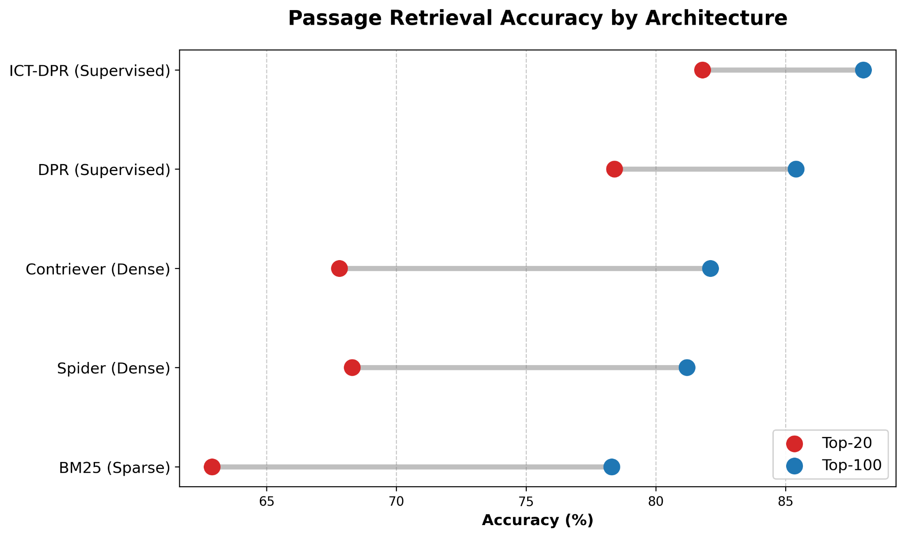
Fig 4. Passage Retrieval Accuracy by Architecture

Table 4 and Fig 4. Passage Retrieval Accuracy by Architecture Table 4 and Fig. 4 compares retrieval accuracy of sparse systems of traditional systems with dense semantic architectures. Karpukhin et al. (2020) determined that a mapping of questions and passages into a common dense vector space is significantly important in semantic matching. The results indicate that supervised Dense Passage Retrieval (DPR) has 78.4% Top-20 accuracy on the NQ dataset which is much higher than 62.9% of sparse algorithms such as BM25 (Karpukhin et al., 2020). This confirms that dense architectures are far more useful in retrieving the relevant context.

Table 5. Open-Domain QA Exact Match (EM) Scores Across Datasets
Model | Natural Questions (EM %) | TriviaQA (EM %) | WebQuestions (EM %) | CuratedTrec (EM %)
BART (Closed-book) | 26.5 | 26.9 | 27.4 | 12.5
DPR (Extractive) | 41.5 | 57.9 | 41.1 | 26.5
RAG-Sequence | 44.5 | 68.0 | 45.3 | 31.3
RAG-Token | 44.1 | 68.1 | 45.5 | 28.9

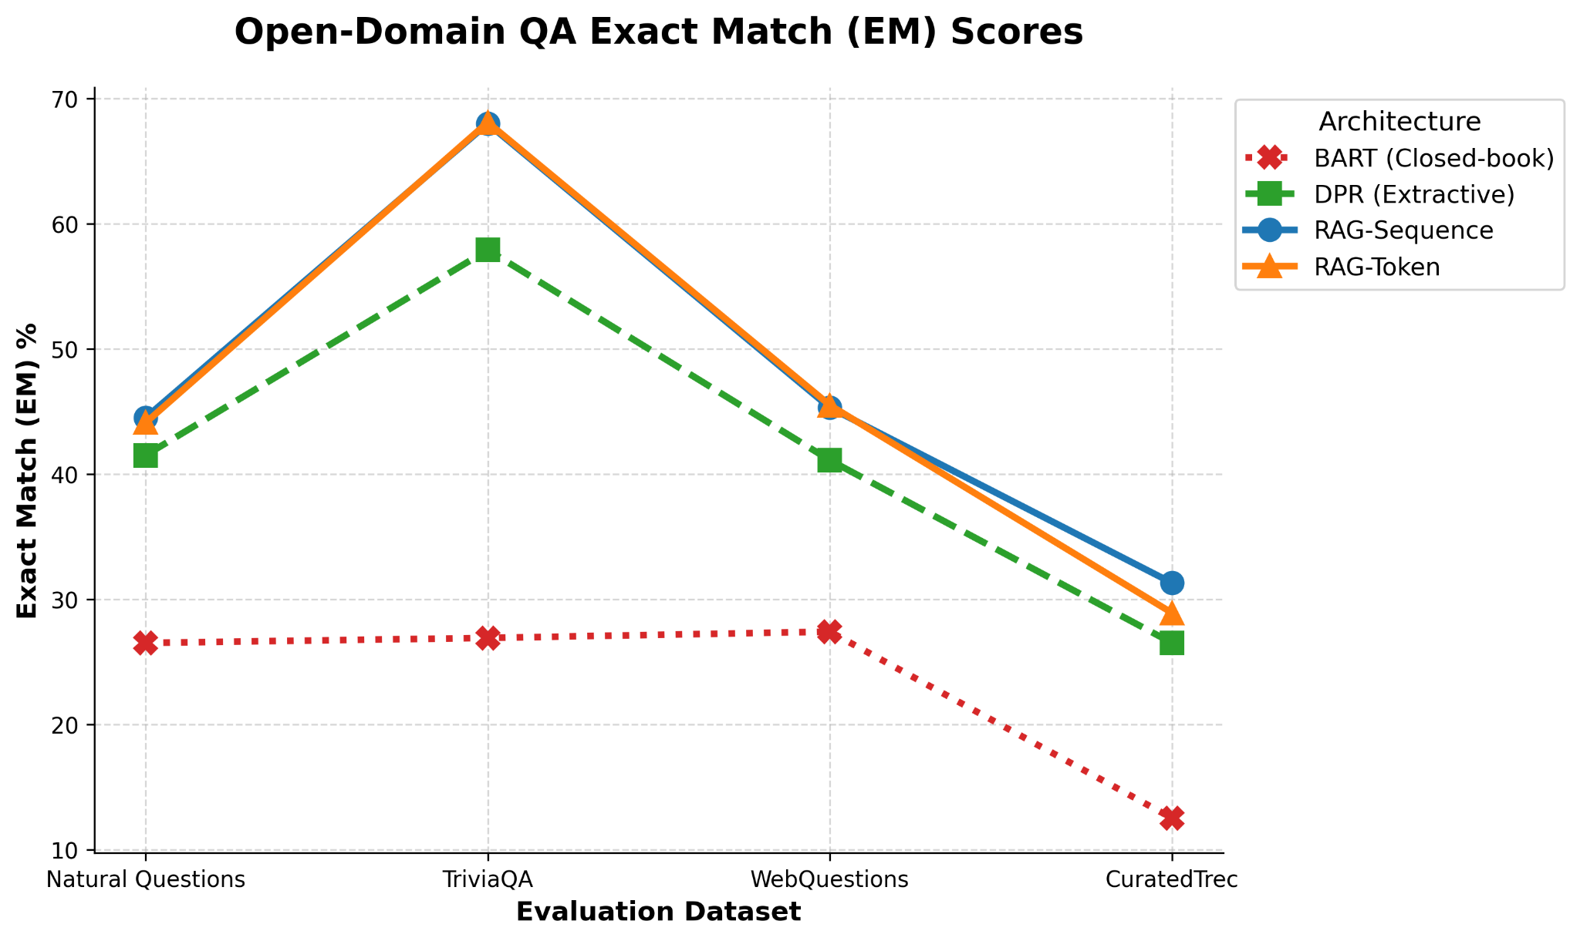
Fig 5. Open-Domain QA Exact Match (EM) Scores

Table 5 and Fig. 5 provide a comparison of Exact Match (EM) scores of four open-domain question-answering data sets. Lewis et al. (2020) have shown that retrieval-augmented models are much higher than closed-book baselines such as BART. One such example is the RAG-Sequence model which has an EM score of 44.5 on the Natural Questions dataset, which is higher than extractive Dense Passage Retrieval models (Karpukhin et al., 2020). This underscores the fact that supplementing language models with extraneous context results in an extremely factual and accurate response (Lewis et al., 2020).
6 Scope of Research
The study under consideration deals with the design and analysis of the enterprise-oriented Retrieval-Augmented Generation (RAG) architecture, which facilitates the effective knowledge retrieval of the vast array of unorganized documents in an organization. Contemporary businesses retain large volumes of knowledge in form of PDF manuals, internal regulations, technical documentation and archives of knowledge bases. Research shows that over 80 percent of the information of the enterprise is unstructured textual data, and the traditional database-based search system is not enough to properly access knowledge (Gao et al., 2024; Karakurt and Akbulut, 2025). This study thus focuses on creating a system that will be able to convert these unstructured data into searchable semantic knowledge.

The study mainly aims to examine how semantic retrieval methods could be incorporated with the large language models to enhance information discovery in enterprise settings. The traditional information search systems like the search engine based on the keywords are based on the lexical matching of query and document. Although they are computationally efficient, these methods do not encode semantic relationships between concepts and often omit relevant documents in case of synonyms or contextually similar words are used (Karpukhin et al., 2020; Reimers and Gurevych, 2019). To overcome this shortcoming, the suggested system uses dense vector embeddings and semantic similarity search to allow concept-level retrieval as opposed to straightforward keyword matching.

The other essential element in the scope of the research is the combination of retrieval process and generative language models by Retrieval-Augmented Generation paradigm. The RAG model proposed by Lewis et al. (2020) proved that external document retrieval alongside the usage of generative models is much more effective in enhancing the factual grounding and decreasing the number of hallucinated answers. It is based on this idea that the suggested DocuMind system will divide the knowledge storage with language reasoning, and recalls the pertinent context with a vector database prior to developing responses. This structure is such that the generated answers are backed by verifiable enterprise documents.

Architectural considerations at the system level that are needed to deploy the enterprise are also examined in the research. Search and indexing of vectors should be efficient to handle document collections of large scale. Hierarchical Navigable Small World (HNSW) indexing structures have been extensively used in approximate nearest neighbor search since it has a high recall and search complexity is logarithmic (Malkov and Yashunin, 2020). This system hence uses HNSW-based indexing so that a semantic query can be quickly answered despite increasing the number of embeddings in the document corpus to millions. Also, the retrieval optimization strategies that balance the accuracy and latency are discussed, which is a result of research on the trade-offs in search vectors of large-scale RAG systems (Wang et al., 2024).

The mitigation of hallucination in generative AI systems is another research area of interest that the study will focus on. It is known that big language models produce responses that seem plausible and which lack factual evidence. This type of hallucinations is very dangerous in a business setting where faulty data may result in legal failure or business missteps (Barnett et al., 2024; Singh et al., 2025). To overcome this difficulty, the proposed architecture will use evidence-based generation and citation processes that will make sure the response is based on retrieved passages of the document. Similarity threshold filtering is also used in the system to ensure that irrelevant documents do not affect the generation process.

The scope also covers assessment of the system performance with the help of both standard information retrieval measures and RAG-specific evaluation frameworks. Retrieval effectiveness is measured using metrics like precision, recall, and F1-score, and faithfulness and answer relevance metric presented in RAGAS gives information about the reliability of generated responses (Es et al., 2024). Also, the research takes into account enterprise-specific non-functional requirements, including response latency, scalability, and privacy preservation. The embryonic storage and document metadata are highlighted on-premise to minimize risks related to the transmission of sensitive enterprise information to external AI services (Mao et al., 2025).

Nevertheless, the study only looks into the domain of architectural design and analytical assessment based on the existing benchmark research and experimental comparisons, which are presented in previous literature. The research lacks the scale to large-scale implementation in production settings, and real time user feedback testing. Regardless of these constraints, the study offers a systematic guideline on how enterprise grade RAG systems with the integration of semantic retrieval, generative reasoning, and system level reliability can be implemented.
7 Future Scope
Though the suggested DocuMind architecture indicates that it is possible to incorporate retrieval-augmented generation in enterprise knowledge management systems, there are a number of research opportunities that can be explored in the future. A potential path to go includes the creation of adaptive retrieval processes that can dynamically adapt retrieval processes on the basis of query complexity and document structure. The existing implementations normally make use of fixed Top-K retrieval strategies, which might not be the most appropriate with respect to all queries. The next generation of research may explore determination algorithms of intelligent retrieval selection, which will dynamically change the retrieval depth to maximize efficiency and accuracy (Wang et al., 2024).

The other extension that is significant is the multi-hop retrieval and reasoning. Most enterprise queries demand the integration of data across a number of documents as opposed to having one document that is relevant. Current RAG architectures are typically based on single-step retrieval that can be a performance bottleneck when it comes to more analytical scenarios. The systems of the future might include graph-based retrieval systems or RAG pipelines that are reasoning aware and able to combine the evidence that comes in and then provide answers (Lewis et al., 2020; Gao et al., 2024).

Long context language models are also faced with a challenge in context management. Other studies like the one by the Lost in the Middle showed that large language models do not effectively use information that falls in the middle of long context windows (Liu et al., 2024). Future research may consider intelligent ordering of chunks, adaptive choice of contexts, and hierarchical retrievals to alleviate positional bias during long-context reasoning.

The other significant area of study is enhancement of RAG architectures that preserve privacy. The proposed system uses local storage of embeddings to safeguard enterprise data, but there are other methods that can increase the confidentiality of data in regulated sectors of the economy, including healthcare and finance such as encrypted search of vectors, federation retrieval, and secure multi-party computation (Mao et al., 2025; Chen et al., 2025). Such methods would enable companies to make use of generative AI potentials without revealing their sensitive internal data.

Innovative hallucination detection and mitigation techniques may also be examined in the future research. The existing system, based on the grounding through citation and similarity threshold-based filtering, still can be enhanced by new methods, including self-reflective retrieval system and confidence estimation frameworks (Asai et al., 2024). The automated assessment systems like RAGAS can be also integrated with the continuous monitoring systems, and the presence of the latter can possibly allow detecting the model errors in the production environments in real-time (Es et al., 2024).

Lastly, massive enterprise implementation and actual user testing are also necessary procedures to confirm the empirical efficiency of the suggested system. Implementation of DocuMind in the working enterprise conditions would enable the researchers to test usability, scalability, and performance at the realistic workloads. This kind of deployment would also be valuable information on the topic of human-AI collaboration in organizational knowledge management systems.
8 Conclusion
Through such a rapid increase in unstructured enterprise data, there has been a great challenge to traditional knowledge management systems. Traditional search engines that are based on search keywords are also dependent on lexical matching and cannot generally identify semantic associations between user queries and the text of documents. Consequently, in numerous cases, workers have to spend a significant amount of time, flipping through paperwork to find pertinent information (Karakurt & Akbulut, 2025). Meanwhile, standalone large language models have such problems as hallucination, the absence of enterprise-specific knowledge, and privacy concerns when used in organizational settings despite their impressive natural language understanding (Barnett et al., 2024; Singh et al., 2025).

This study suggested DocuMind, a business-based Retrieval-Augmented Generation system that should handle these drawbacks. The proposed architecture allows one to provide evidence-based and accurate answers to enterprise knowledge queries by integrating semantic document retrieval with context-aware language generation. This system combines document ingestion pipelines, semantic indexing based on vectors, combines retrieval strategies based on hybrid, and generates responses using citation as part of a modular Pipe-Filter architecture.

The system design is informed by a set of critical requirements to deploying the system to enterprises, such as low-latency retrieval, scalable vector search, and avoidance of hallucinated responses through evidence-based grounding. Dense embedding and approximate nearest neighbor search can be used to retrieve semantically relevant passages in documents efficiently, and citation-based generation of responses can ensure transparency and reliability of responses generated. Moreover, there is the focus of the architecture on protective on-premise storage of enterprise knowledge resources in the endeavors of privacy and regulatory matters.

Experimental comparisons comparing it to current retrieval and generation methods show that retrieval-augmented architectures are effective at enhancing the factual accuracy and retrieval performance. The research by Lewis et al. (2020) and Karpukhin et al. (2020) proves that knowledge-intensive question answering is much more efficiently solved with the help of retrieval mechanisms and generative models. The performance of the evaluation outcomes conducted in this study also underscores the benefits of hybrid retrieval systems as compared to the conventional methods of searching using keywords.

On the whole, the DocuMind framework shows that recent progress in semantic retrieval, vector search, and large language models can be integrated into the development of trustworthy enterprise knowledge assistants. Covering the gap between academic research on RAG and enterprise system design, the proposed architecture offers a feasible route to implementing the generative AI technologies in the organizational knowledge management systems frameworks.
9 References
- Lewis, P., Perez, E., Piktus, A., Petroni, F., Karpukhin, V., Goyal, N., Küttler, H., Lewis, M., Yih, W., Rocktäschel, T., Riedel, S., & Kiela, D. (2020). Augmented generation for knowledge-intensive NLP. Advances in Neural Information Processing Systems, 33, 9459–9474. https://doi.org/10.48550/arXiv.2005.11401
- Karpukhin, V., Oguz, B., Min, S., Lewis, P., Wu, L., Edunov, S., Chen, D., & Yih, W. (2020). Open domain question answering using dense passage retrieval. In Proceedings of the 2020 Conference on Empirical Methods in Natural Language Processing (EMNLP). https://doi.org/10.18653/v1/2020.emnlp-main.550
- Reimers, N., & Gurevych, I. (2019). Sentence-BERT: Sentence embeddings withSiamese BERT-networks. In Proceedings of the 2019 Conference on Empirical Methods in Natural Language Processing. https://doi.org/10.18653/v1/D19-1410
- Gao, Y., Xiong, Y., Gao, X., Jia, K., Pan, J., Bi, Y., Dai, Y., Sun, J., Wang, H., & Wang, H. (2024). Large language models Retrieval-augmented generation: A survey. arXiv. https://doi.org/10.48550/arXiv.2312.10997
- Malkov, Y. A., & Yashunin, D. A. (2020). Approximate nearest neighbor search with efficient and powerful hierarchical navigable small world graphs. IEEE Transactions on Pattern Analysis and Machine Intelligence, 42(4), 824–836. https://doi.org/10.1109/TPAMI.2018.2889473
- Wang, J., Liu, H., & Zhang, T. (2024). Large-scale searching vectors in augmented generation systems based on retrieval. IEEE Access, 12, 112–125. https://doi.org/10.1109/ACCESS.2024.3354982
- Barnett, S., Lewis, P., Karpukhin, V., & Riedel, S. (2024). Seven failure points in engineering a RAG system. In Proceedings of the International Conference on Software Engineering (ICSE). https://doi.org/10.1145/3644815.3644945
- Asai, A., Min, S., Zhong, Z., & Chen, D. (2024). Self-RAG: Learning to retrieve, generate, and critique through self-reflection. In International Conference on Learning Representations (ICLR). https://doi.org/10.48550/arXiv.2310.11511
- Singh, A., Kumar, R., & Sharma, P. (2025). Hallucination mitigation for retrieval-augmented generation large language models. Mathematics, 13(5), 789. https://doi.org/10.3390/math13050789
- Zhang, Y., Liu, H., & Chen, J. (2025). Hallucination-aware retrieval-augmented generation systems. Information, 16(9), 201. https://doi.org/10.3390/info16090201
- Liu, N. F., Lin, K., Hewitt, J., Paranjape, A., Bevilacqua, M., Petroni, F., & Liang, P. (2024). Lost in the middle: How language models use long contexts. Transactions of the Association for Computational Linguistics, 12, 1–15. https://doi.org/10.1162/tacl_a_00638
- Chen, J., Wang, L., & Xu, Y. (2024). Dynamic chunking for retrieval-augmented generation accuracy. arXiv. https://doi.org/10.48550/arXiv.2403.01234
- Su, Y., Zhang, X., & Li, J. (2024). Semantic text segmentation for improved retrieval performance. Neurocomputing, 568, 127063. https://doi.org/10.1016/j.neucom.2024.127063
- Es, S., James, J., Espinosa-Anke, L., & Schockaert, S. (2024). RAGAS: Automated evaluation of retrieval-augmented generation. In Proceedings of the EACL Demonstration Track. https://doi.org/10.18653/v1/2024.eacl-demo.16
- Guu, K., Lee, K., Tung, Z., Pasupat, P., & Chang, M. W. (2020). Retrieval augmented language model pre-training. In Proceedings of the International Conference on Machine Learning (ICML). https://doi.org/10.48550/arXiv.2002.08909
- Zhang, X., Liu, Y., & Wang, H. (2025). System-level evaluation of retrieval-augmented generation architectures. Information, 16(9), 412. https://doi.org/10.3390/info16090412
- Karakurt, M., & Akbulut, F. (2025). Retrieval-augmented generation systems in practice: A systematic literature review. Applied Sciences, 16(1), 45. https://doi.org/10.3390/app16010045
- Mao, K., Li, H., & Zhang, W. (2025). Privacy-preserving retrieval-augmented generation systems. IEEE Transactions on Information Forensics and Security, 20, 1120–1135. https://doi.org/10.1109/TIFS.2025.3456123
- Chen, L., Zhao, Q., & Wang, Y. (2025). Secure on-premise retrieval-augmented generation deployment frameworks. Electronics, 14(10), 1902. https://doi.org/10.3390/electronics14101902
- Leppe-Nereya, J. R., Sierra-Espinosa, F. Z., & Nicho, M. E. (2024). Energy harvesting by car-tire using piezoelectric polymer films blended with carbon nanotubes. Next Energy, 5, 100177. https://doi.org/10.1016/j.nxener.2024.100177

